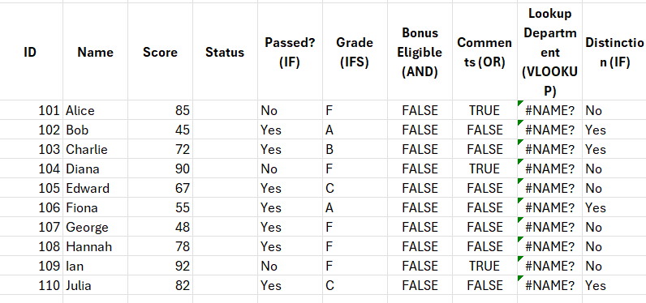

Excel Conditional Formulas and Their Uses
- IF: Tests a condition and returns one value if TRUE, another if FALSE. Basic syntax: =IF(condition, value_if_true, value_if_false) used for simple decision-making.​
- IFS: Tests multiple conditions in sequence, returning a value corresponding to the first TRUE condition. Useful for multiple branching logic.​
- AND: Returns TRUE if all conditions are TRUE; often combined with IF for multiple condition checks.​
- OR: Returns TRUE if any condition is TRUE; useful in IF to check multiple options.​
- NOT: Reverses TRUE to FALSE or vice versa, used to negate conditions.​
- SUMIF/SUMIFS: Sum cells that meet one or multiple criteria, respectively.​
- COUNTIF/COUNTIFS: Count cells meeting single or multiple criteria.​
- MINIFS/MAXIFS: Find minimum or maximum values under specific criteria.​
- SWITCH: Returns a value from a list based on matching an expression, simpler than nested IF for fixed options.​
Distinctions Between Formula Types
- Logical Functions (IF, AND, OR, NOT) test conditions to return logical TRUE/FALSE or conditional outputs.
- Conditional Aggregates (SUMIF, COUNTIF) operate on ranges to sum/count based on conditions.
- Single vs Multiple Conditions: IF can handle one condition, IFS or nested IFs handle multiple conditions.
- Exact vs Approximate Matching: Important in lookup functions like VLOOKUP, where match type affects results.
Theory of VLOOKUP in Excel
- VLOOKUP("Vertical Lookup") searches for a value in the first column of a range and returns a value from a specified column in the same row.​
- Syntax: =VLOOKUP(lookup_value, table_array, col_index_num, [range_lookup]).
  - lookup_value: Value to search.
  - table_array: Range of cells containing data.
  - col_index_num: Column number within table_array to return value from.
  - range_lookup: TRUE for approximate match, FALSE for exact match.
- Useful for retrieving data like prices, names based on IDs, or any key-value relation.
Theory of IF ELSE Statement in Excel
- IF ELSE logic in Excel is implemented by the IF function: "IF this condition is true, then do this, else do something else".​
- The value_if_false parameter acts as the ELSE clause.
- Nested IFs (IF inside IF) allow multiple ELSE IF branches.
- Supports integration with AND, OR, NOT for complex conditions.
- Example: =IF(A1>100, "Yes", "No") means if A1 is greater than 100 return "Yes", else return "No".
This covers the essential conditional functions, their key differences, and the foundational concepts behind VLOOKUP and IF ELSE statements in Excel.
If you want, a detailed table listing formulas, their structure, and use cases can be provided next. Would you likeou like that?

